
2025-26

STUDENT HANDBOOK

School Hours
8:30 a.m. – 3:30 p.m.

Office Hours
7:30 a.m. – 4:30 p.m.

919 Smith Street
Midland, MI 48640
Phone (989) 832-0852
Fax (989) 839-7699

VISION STATEMENT

A quality education: A life-changing experience.

MISSION STATEMENT

To provide the social and academic skills that will guarantee successful high school completion in an alternative learning environment that accepts the individual challenges while enhancing the strengths of all students enabling them to become successful, contributing members of the community.
BOARD APPROVED: May 21, 2025

INTRODUCTION

Welcome to Windover High School. Windover has existed for over 30 years as a high school, serving Midland County and surrounding communities. We are pleased to have you join our Windover family. I hope that you will find your time here to be both challenging and rewarding. We strive to provide our Bulldogs with many of the same opportunities they would find at other area schools AND offer the personal connection with peers and school staff to make it feel like they are home.

Our high school team is committed to providing every student with a safe, caring, and positive learning environment that encourages each student to realize and desire to reach their full potential – academically and as a member of our community. We believe this is critical to students graduating on time and becoming productive members of our community.

This handbook will provide answers to many questions you may have regarding our school. Please read it carefully and completely since it addresses policies and procedures that pertain to you – the student. All students must sign a card indicating they have been given a current Student Handbook and have received an oral presentation, summarizing its major points.

We are here to facilitate your success through graduation. If you need additional information, please feel free to call the school at (989) 832-0852. My office is always open to you. You can visit our website—www.windover.org—to obtain the most current information about school events.

Best wishes for a productive and exciting year!

Scott Hewitt, Principal/CAO
shewitt@windover.org
Windover High School

TABLE OF CONTENTS

VISION & MISSION STATEMENT 1
INTRODUCTION 2
WINDOVER STAFF AND BOARD OF DIRECTORS 6
SCHOOL CALENDAR 7
DAILY SCHEDULE 8
GENERAL BUILDING INFORMATION/EXPECTATIONS 9-13
ARRIVAL AND DEPARTURE FROM SCHOOL 9
ATTENDANCE POLICY 9
ATTENDANCE CONTRACT 9
TRUANCY POLICY 9
PARENT RESPONSIBILITY 10
CLOSED CAMPUS POLICY 10
DIRECTORY INFORMATION 11
DUAL ENROLLMENT & SPECIAL PROGRAMS 11
ELIGIBILITY 11
LUNCH 11
MANDATED REPORTERS 11
PEST MANAGEMENT 12
SAFETY DRILL PROCEDURES 12
SCHOOL CANCELLATIONS 12
TRANSPORTATION 12
STATEMENT OF NONDISCRIMINATION 13
FAMILY RIGHTS AND PRIVACY ACT 13
VISITORS 14
BANNING OF THE CONFEDERATE FLAG AND SWASTIKAS 14
ACADEMICS 14-17
CREDITS REQUIRED FOR GRADUATION 14
ACADEMIC PROFICIENCY 14
PERFORMANCE CONTRACTS 15
SOURCES OF CREDIT 15
TESTING FOR CREDIT 15
CERTIFICATE OF COMPLETION 16
ASSIGNMENT OF GRADE LEVEL 16
GRADE LEVEL ACADEMIC REQUIREMENTS 16
MISSING ASSIGNMENTS 17
TEST RETAKES 17
ADVISORY 18
BULLDOG BELIEFS 18
VOICE LEVELS 20
BULLDOG BUCKS 20
BEHAVIOR EXPECTATIONS 21-25
AGGRESSIVE PHYSICAL CONTACT 21
CELL PHONES AND ELECTRONIC DEVICES 21
DRUGS & ALCOHOL 21
EXTORTION 22
GANG ACTIVITY 22
HARASSMENT 22
OBSCENITY AND INDECENCY 22
DRESS CODE 23
PLAGIARISM/CHEATING 24
STEALING 24
USE OF TOBACCO PRODUCTS 24
VANDALISM 24
VERBAL ASSAULT 24
WEAPONS 24
ARSON 24
VIOLENCE OR THREAT OF VIOLENCE (TO STUDENT OR STAFF) 24
CRIMINAL SEXUAL CONDUCT 24
MANDATORY EXPULSIONS 25
SEARCH & SEIZURE 26
SECLUSION & RESTRAINT 26
RESPONSES AND INTERVENTIONS 26-29
RESTORATIVE PRACTICES 26
RESPONSIVE CIRCLES 26
RESPONSIVE MEETING 27
RESTORATIVE CONFERENCE 27
MINDFULNESS 27
SUSPENSION PROCEDURE 27
SNAP SUSPENSION 28
EXPULSION PROCEDURE 28
REINSTATEMENT PROCEDURES 29
WEAPONS REPORTING 30
BULLYING POLICY 31-33
COMPUTER USAGE POLICY 35-40
CONSEQUENCES 35
CHROMEBOOK USE 36-40
RECEIVING A CHROMEBOOK 37 TAKING CARE OF CHROMEBOOK 37
RETURNING A CHROMEBOOK 38
FINES RELATED TO A CHROMEBOOK 38
CLAIMS 38
PERSONAL HOME & HOMEOWNERS/RENTERS COVERAGE 39
USING CHROMEBOOK CAMERA 39
LEGAL PROPRIETY 39
SCREENSAVERS/BACKGROUND PHOTOS 39
SOUND, MUSIC, GAMES, SOFTWARE/APPS 39
USING A CHROMEBOOK AT SCHOOL 40
CHROMEBOOK UNDERGOING REPAIR 40
NETWORK CONNECTIVITY 40

ADMINISTRATION

SCOTT HEWITT
PRINCIPAL/
CHIEF ADMINISTRATIVE OFFICER (CAO)

BOARD OF DIRECTORS

CHERI KING
PRESIDENT

MARY YEOMANS
SECRETARY

KYLE ANDERSON
TREASURER

BETH DeVries
BOARD MEMBER

BETSY RAU
TRUSTEE

CARIN DALY
RECORDING SECRETARY

TEACHERS

BRIAN CLENNAN
CULINARY ARTS

EMILY ROTH

ELECTRONIC FACILITATOR/SPECIAL EDUCATION

ALEXANDER GLEISSNER
CIVICS/ECONOMICS/
HISTORY/SOCIAL STUDIES

TEACHERS CONT.

HAELEY HUGGARD
ENGLISH/ONLINE

ROBERT BLAINE
SPECIAL EDUCATION/PSYCHOLOGY

JULIE WELLS
ART

DANA DRAPER-ROSIN
MATH SUPPORT
STEM/ONLINE

SUPPORT STAFF

TAMMY MOORE
ADMINISTRATOR ASSISTANT

SALLY BILLOTTI
READING TUTOR

CARRIE ELLIS
OFFICE –ACCOUNTING
TRANSPORTATION

JAN FOWLER
OFFICE – STUDENT SERVICES

STEPHEN DILLON
SCHOOL NUTRITION COORDINATOR

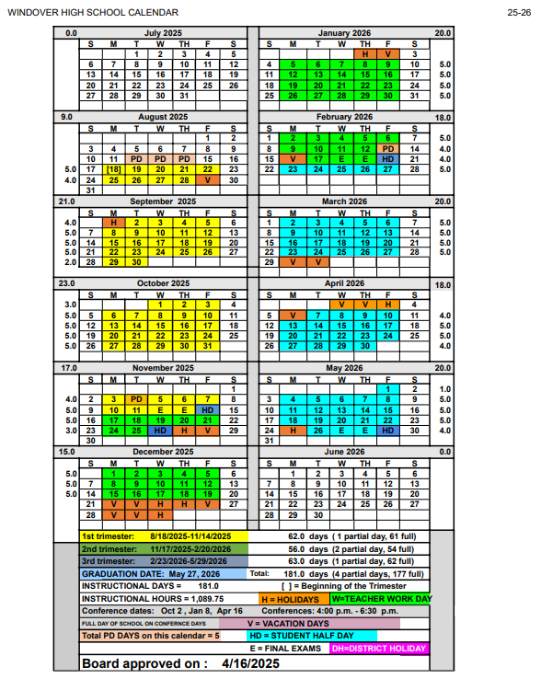

DAILY SCHEDULE
2025-2026

BREAKFAST SERVED FROM 8:00 A.M. – 8:30 A.M. DAILY

ADVISORY 8:30 – 9:00 A.M.

PASSING TIME 9:00 - 9:05 A.M.

BLOCK ONE 9:05 – 10:14 A.M.

PASSING TIME 10:14 – 10:18 A.M.

BLOCK TWO 10:18- 11:27 A.M.

PASSING TIME 11:27 – 11:31 A.M.

BLOCK THREE 11:31 – 12:40 P.M.

LUNCH BREAK 12:40 – 1:08 P.M.

BLOCK FOUR 1:08 – 2:17 P.M.

PASSING TIME 2:17 – 2:21 P.M.

BLOCK FIVE 2:21 – 3:30 P.M.

CLASSES END 3:30 P.M.

GENERAL BUILDING EXPECTATIONS/INFORMATION

ARRIVAL AND DEPARTURE FROM SCHOOL
Upon arrival at school students must immediately report to designated morning areas and remain there until 8:25 a.m. Classes end at 3:30 p.m. Students should report to the bus immediately as the buses depart at 3:35 p.m. All other students are expected to leave the building and school grounds by 3:35 p.m. as well. Only students with permission can remain in the building after dismissal. Students are not allowed to arrive at school after 12:35 p.m. without permission.

ATTENDANCE POLICY
Students are expected to be in school on time every day and remain for the entire day - from 8:30 a.m. until 3:30 p.m. Good attendance allows the student to earn credits more rapidly. Medical and other appointments should be scheduled for after school hours to allow the student to be in school all day every day. Parents are asked to call the school at (989) 832-0852 to report student absences, which will be recorded in the main office.

An absence at Windover High School is considered excused for the following reasons:
- Illness
- Funeral
- Doctor/dental appointment
- Court appointment
- Counseling
- Family related issues
- Other absences may be excused on a case-by-case basis

Excused absences are documented by parent phone calls or notes, doctor/dental notes, and our student sign-out sheets required for leaving during the school day.

ATTENDANCE CONTRACT
If a student’s attendance falls below 90% for 1 week in a row, he/she may be given an attendance contract to sign. If the student continues to attend less than 90% of the time, the student may be dropped from Windover High School. Any student, dropped due to poor attendance, can request to have his/her name placed on the waiting list for possible re-admittance, as space becomes available. Per administrative discretion, the student may be dropped at any time their attendance drops below 90% without receiving an attendance contract.

Extenuating circumstances for continuing absences should be discussed and documented with the principal. Students and their parents may ask in writing for reconsideration of the student’s particular case. This must be done within one week (7 days) of the exclusion of the student from Windover High School. A meeting with the student, parent, principal and at least one teacher will be held as soon as possible to discuss the situation. The principal will notify the parents or student of the decision the following day.

TRUANCY POLICY
School truancy is a serious concern for our youth in Midland County. Truancy is not only detrimental to success in education, but is a stepping-stone to delinquent and criminal activity. Reports have concluded that chronic absenteeism is the most powerful predictor of delinquent behavior.
The Midland County School and Court Truancy Program is a collaborative effort between the Midland County Probate Court, 42nd Circuit Court – Family Division, the 75th District Court, Midland County Prosecuting Attorney’s Office, Community Mental Health of Central Michigan in Midland County and Midland County Public Schools. The program addresses truancy with a continuum of interventions starting with a parent letter and parent meetings with the school, a mental health screening by the Youth Intervention Specialist, a meeting with the Court Services Coordinator and, as a last resort, Court intervention.
For a child who turns age 11 on or after December 1, 2009 or a child who was age 11 before that date and enters grade 6 in 2009 or later, he/she will be held to attendance requirements the State of Michigan’s Compulsory Education Law dictates. This law requires students to attend school regularly, with minimal absence, until the student graduates or turns 18. Please see the next section on Truancy for more details about this law.
If a student falls under the requirements of Michigan’s Compulsory Education Law, good attendance is a requirement. These students are allowed up to 5 unexcused absences between September and the end of January, and up to 5 unexcused absences between February first and the end of school in June.

Parent/Guardian Responsibility:
It is the responsibility of the parent(s)/guardian(s) to see that their child attends school regularly
and on time. By law, "every parent, guardian, or another person in this state having control and
charge of a child from the age of six to the child’s eighteenth birthday, shall send that child to the
public schools during the entire school year.” Violation of this law is a misdemeanor punishable
by up to 90 days in jail and/or a fine. Exceptions to this law exist, including attendance at
approved non-public schools and homeschooling. MCL 380.1599

A meeting will be held with student, parent and school truancy officer if a student nears 5 unexcused absences. If the student then misses 3 days (unexcused) within the next three months or 2 days (unexcused) within the next 30 days a truancy conference will be held with Jodie Garner, school administrator, parent and student at the Midland County CourtHouse.

If a student has unexcused absences after the meeting at the CourtHouse, the school is required to file a Truancy Petition and the Court Services Coordinator, Jodie Garner, will take over the case and put the student on probation.

If a student is on probation for truancy and continues to be absent from school a violation of probation will be filed. The student will have to appear before a judge and could be put in the Juvenile Care Center (JCC). Penalty fees will apply for those put on probation, sent to JCC and for parents and students failing to comply with requirements of the law.

Midland County Truancy Program:
https://co.midland.mi.us/Portals/0/Midland%20County/Documents/Probate%20Court/Combined%20File%20Truancy%20Protocol.pdf

CLOSED CAMPUS POLICY
Windover High School has a closed campus for all students except those who are 18. 18 year olds students may leave for lunch and return for their fourth and fifth block classes. 18 year old students may leave at lunch provided they:
- Leave in a vehicle
- Sign out and sign back in BEFORE 1:08 PM
Closed campus also means that students’ friends may not come to visit or be on school grounds during school hours without permission. All students must sign out at the front office prior to leaving the building. Minor students must have permission from their parents or guardians to leave the school building. Any student who leaves the school building early without signing out in the front office and/or without parental permission will receive a discipline referral for skipping.

Once a student is signed out or sign out they will not be able to return to the building or utilize Windover High School provided transportation unless they have prior permission or are an 18 year old leaving for lunch.

DIRECTORY INFORMATION
As part of the enrollment packet, parents or eligible students will be asked to sign a “Permission to Release Directory Information” form. Parents or eligible students shall advise the school district, in writing, of any and all items they refuse to permit the district to designate as directory information for the balance of the school year. The following items are designated as student directory information: Name, address, date of birth, grade level, photograph, previous school attended, and parents’ names.

DUAL ENROLLMENT AND SPECIAL PROGRAMS
In accordance with the Post-secondary Options Act Update for 2000 and the Career and Technical Preparation Post-secondary Options Act, Windover High School provides the opportunity for dual enrollment in a post-secondary institution (state university, community college, or independent nonprofit degree-granting colleges or universities located in Michigan) for ALL ELIGIBLE STUDENTS.

Eligible students may enroll in post-secondary courses for high school credit or postsecondary credit or both. Windover High School is responsible for the cost of tuition, fees, and books for up to the equivalent cost of one class at Windover High School for each college class a student enrolls. The student is responsible for any costs that exceed the school’s portion of the college expenses. Please meet with the school administration for more information.

Windover high school students have the opportunity to participate in the Great Lakes Bay Early College. The program takes place on SVSU's campus. Students have the opportunity to earn high school and college credit simultaneously.

Additionally in special circumstances, on a limited basis, certain students are eligible to take all online courses through a seat-time waiver. However, students who participate in this option are only eligible to earn 5 credits per school year.

ELIGIBILITY
Windover High School is a school of choice and is open to all 9th – 12th-grade high school students. A student who turns 20 by September 1 of the current school year is not eligible to enroll. A student who is in their 9th-grade year can enroll.

LUNCH
Lunch is prepared and served at Windover on a daily basis. All students receive free breakfast and lunch. Students are expected to eat lunch in the designated area, and are to remain in that designated area for the duration of the lunch period unless they are given permission. Students have approximately 28 minutes for lunch. Students may not order lunch from an outside vendor and have it delivered. If lunch is being dropped off to a student by a parent or guardian, the food must arrive and be consumed during the 12:44 – 1:08 p.m. lunch period.

MANDATED REPORTERS
All school personnel, including teachers and administrators, are required by law
to immediately report any and all suspected cases of child abuse or neglect to
the Michigan Family Independence Agency.

PEST MANAGEMENT
Windover High School has a licensed contractor conduct monthly inspections of its facility. Procedures will be used to determine when to control pests and whether to use mechanical, chemical, or biological means. Records will be kept on site documenting pest sightings and the applications of any necessary pesticides. Any pesticide application will be conducted by licensed technicians following all federal and state safety guidelines. A copy of the Pest Management Plan and the service schedule is available upon request. Any parent who would like to be notified prior to a pesticide application may submit their request in writing to the principal.

SAFETY DRILL PROCEDURES
Safety drills will occur at times established by the school board. Students are required to be silent and shall comply with the directives of school officials during emergency drills. Each school shall conduct a minimum of five (5) fire drills, two (2) tornado drills, and three (3) lock-down drills each school year. There may be other drills at the direction of the administration. Drills will not be preceded by a warning to the students.

SCHOOL CANCELLATIONS
When weather conditions or mechanical failures dictate the closure of Windover High School, it will be announced on the following radio and TV stations:
WKQZ 93.3 FM
WHNN 96 FM
WNEM TV 5
WEYI 25 NEWS
Or, you can check the school’s website and Facebook page: www.windover.org and/or www.facebook.com/windoverhigh/ and/or School Messenger.

Parents/Guardiansand students will need to provide Windover with the most updated phone number and email for the most accurate information regarding school closing and other pertinent school information.

TRANSPORTATION
Transportation will be provided to any student who enrolls at Windover High School, lives in Midland County, and requests it. The purpose of this service is to provide students a ride to attend school. The Code of Student Conduct applies to students while being transported to and from school as well as on school field trips. Transportation is a privilege and not a required service provided by the school. If students abuse the privilege by not utilizing the transportation that has been arranged, they may lose access to transportation services. All misconduct on transportation will receive consequences.

Students who drive to school must be legally licensed and must register their vehicle with the office. The vehicle must be insured and meet all state requirements to be driven on Michigan roads. Forms are available in the office. Students are asked to park in the large lot to the east of the building. Reckless driving will result in the student losing the privilege to drive to school. All drivers are expected to act responsibly, follow all traffic laws both in the neighborhood and in the parking lot area.

Windover accepts no liability for the safety of students and their passengers driving to or from school. Students are not allowed to loiter in the parking lot, and student(s) are not allowed to return to their vehicle unless a school official has given the authorization to do so. Students are not allowed to sit in any vehicle once it has been parked. Any student that drives off school grounds without proper authorization and takes any passengers with them will lose parking privileges and face disciplinary action of up to 10 days of suspension. Students do not have any expectation of privacy while in a vehicle at any time while on campus.

STATEMENT OF NONDISCRIMINATION
FOR
TITLE VI OF THE CIVIL RIGHTS ACT OF 1964
TITLE IX OF THE EDUCATION AMENDMENT ACT OF 1972
TITLE 11 OF THE AMERICANS WITH DISABILITIES ACT OF 1990
SECTION 504 OF THE REHABILITATION ACT OF 1973
AGE DISCRIMINATION ACT OF 1975

Windover High School is an equal opportunity/affirmative action institution. In compliance with Title VI of the Civil Rights Act of 1964, Title IX of the Education Amendments of 1972, Title II of the Americans with Disabilities Act of 1990, Section 504 of the Rehabilitation Act of 1973, the Age Discrimination Act of 1975, and the State of Michigan's Elliot-Larsen Civil Rights Act of 1977, it is the policy of Windover High School that no person on the basis of race, color, religion, national origin or ancestry, age, sex, marital status, sexual orientation or disabilities shall be discriminated against, excluded from participation in, denied the benefits of, or be otherwise subjected to discrimination in employment or in any program or activity for which the Board is responsible or for which it receives financial assistance from the United States Department of Education.

Any person believing that Windover High School or any part of the school organization has inadequately applied the principles of the aforementioned Acts, may forward a complaint to the ESP Consultant of Windover High School at the following address:

Cheryl King, President
Board of Directors
919 Smith Road
Midland, MI 48640

A written statement of the entire complaint procedure will be furnished by the principal upon request.

FAMILY RIGHTS AND PRIVACY ACT

Parents and eligible students* have the following rights under the Family Educational Rights and Privacy Act of 1974 (FERPA):
- The right to inspect and review the student’s education record.
- The right to exercise a limited control of other people’s access to student records.
- The right to seek to correct the student’s education record if believed to be in error.
- The right to report violations of FERPA to the U.S. Department of Education concerning alleged failures by Windover High School to comply with the requirements of FERPA. Contact the office at:
Family Policy Compliance Office
U.S. Department of Education
400 Maryland Ave SW
Washington, DC 20202-4605
- The right to be informed about FERPA rights.
*All rights and protections given to parents under FERPA and this procedure transfer to the student when he or she reaches the age of 18 or enrolls in a post-secondary school. The student then becomes an "eligible student."

VISITORS
All visitors, including parents and siblings, are required to enter through the front door of the building and proceed immediately to the main office. Visitors should identify themselves and inform office personnel of their reason for being at school.

Visitors must sign in, identifying their name, the date and time of arrival, and the classroom or location they are visiting. Approved visitors must take a tag identifying themselves as a guest and place the tag to their outer clothing in a clearly visible location. Visitors are required to proceed immediately to their location in a quiet manner. All visitors must return to the main office and sign out before leaving the school.

Visitors are expected to abide by all school rules during their time on school property. A visitor who fails to conduct himself or herself in an appropriate manner will be asked to leave and may be subject to criminal penalties for trespass and/or disruptive behavior.

Banning of Confederate Flag and Swastika
It is WHS’ goal to provide our students with a safe learning environment where they are valued and accepted, regardless of race, color of their skin, religion, sexual orientation, gender, etc. We are taking responsibility to educate ourselves and take up the all-encompassing model of equity, inclusion and anti-racism. Windover High School is banning the Confederate flag and Swastikas from school campus and all school-sponsored events.
ACADEMICS

CREDITS REQUIRED FOR GRADUATION*
4.0 Credits English
4.0 Credits Math
3.0 Credits Science
3.0 Credits Social Studies (U.S. & World History/Civics/Econ)
1.0 Credits Health/ Physical Education
2.0 Credits Foreign Language**
1.0 Credits Arts (Visual, Performing, Applied)
4.0 Credits Electives
Total 22 Credits

To be eligible for graduation, a student must earn at least 2.5 credits and complete one trimester through the Windover program. The student must be enrolled no later than the third week of the trimester in which he/she intends to graduate. All work must be completed by the last day of the school year.
*These graduation requirements do NOT pertain to Windover High School students attending the GLBEC program. **Foreign Language may be substituted.

Once a student has completed the required courses they are eligible to graduate with a Windover High School diploma. The soonest a student is eligible for graduation is trimester one of their original cohort year. If a student has an extenuating circumstance and would like to graduate prior to their cohort year they must submit a request to the board of directors.

ACADEMIC PROFICIENCY
Windover High School understands that some students may come lacking not only credit but also skills that are essential to their success as a student and a learner. With this in mind, intervention courses in ELA and math may be offered each trimester. Students who are assessed and found to be deficient in ELA and/or math will be required to take these intervention courses as part of their schedule.

Students or parents can request a personal curriculum to modify a student's graduation requirements. For more information, please speak with the school counselor or principal.
The following grading scale will be applied:

93-100 A
90-92 A-
87-89 B+
83-86 B
80-82 B-
77-79 C+
73-76 C
70-72 C-
67-69 D+
63-66 D
60-62 D-
59% E

PERFORMANCE CONTRACTS
Students are expected to maintain good behavior, attendance, and earn credit towards graduation. If a student is not consistently meeting this standard, he or she will be placed on a performance contract. The principal, in conjunction with the teacher(s), will draft the contract. The contract will delineate the changes in performance and attitude needed to increase the student’s level of success. Failure to change the behaviors will result in the student receiving consequence up to dismissal from Windover High School.

SOURCES OF CREDIT*
- Previously earned high school credit
- Approved college credits
- Independent study
- Testing for credit
- Approved online courses

All of the above sources of credit must be approved by Windover High School administration or designee.
*These options do NOT pertain to Windover High School students attending the GLBEC program.

TESTING FOR CREDIT
Core Content
In compliance with the Michigan Merit Curriculum Law, students can attempt to “test out” of a course. Students who attain a score of 70% or higher on a course assessment identified by the district will receive credit for the course. These assessments will be a sound demonstration that a student meets or exceeds the content expectations associated with the subject credit area. Because some end-of-year tests do not serve as comprehensive measures of content and skill “mastery” as expressed in the Michigan Merit Curriculum Law, students may be required to demonstrate a reasonable degree of mastery either through a written examination, written papers, portfolios, and/or other comparable forms.
Credit for a course earned by a student through the test out process will be used to fulfill graduation requirements and will be counted toward the total required number of credits needed for graduation. It will not be calculated into the student's grade point average (GPA). A student who tests out of a higher level course may not receive credit for a course that is in the same area and lower in the course sequence.

Elective Credit
A student may earn up to six elective credits through testing. Students may take up to four tests or 2 credits per trimester.
To be eligible to attempt to test out of elective credit a student must a
- Have an average of 80% attendance (weekly)
- Complete a skills packet or work with Windover High tutor
- Be present at school for the day of testing
- Be in good academic standing in each class in which the student is enrolled
- Be actively engaged in his/her education*
- Be in the current graduation cohort or whose cohort has already graduated
- Have completed one full trimester at Windover High School

*A student who misses a testing date will not be allowed to test on an alternative date unless they have prior approval from the testing administrator. Any student who is suspended or asked to leave school on a testing day will not be allowed to make up the test.

CERTIFICATE OF COMPLETION
Some students may be on track to earn a Certificate of Completion rather than a Michigan Merit Diploma. In order for a student to have a Certificate of Completion, they must have it listed as a target in their Individual Education Plan. The curriculum necessary for a certificate of completion will be developed by the IEP team on a student by student basis.

A student does not have to meet the criteria of the Michigan Merit Curriculum or maintain the grade requirement to receive a certificate of completion. A student with an IEP may focus on meeting individualized goals and objectives. The student’s IEP team determines if he/she will receive a diploma or a certificate of completion. A student who receives a certificate of completion is eligible to continue receiving special education services until the age of 26 per Michigan Administrative Rules for Special Education (MARSE) Rule 340.1702

ASSIGNMENT OF GRADE LEVEL
A student’s grade level is set at the beginning of the academic year based on the number of credits earned to date. The student’s grade level will be adjusted to 12th grade prior to exiting. Grade level is also contingent on achieved academic requirements.

GRADE LEVEL ACADEMIC REQUIREMENTS*
9th-grade courses Credits needed
English 1
Math 1
Science or Social Studies 2
PE, Health, or elective 1.5

10th-grade courses Credits needed Cumulative Credits
English 1 2
Math 1 2
Science or Social Studies 2 4
PE, Health, or elective 1.5 3

11th-grade courses Credits needed ** Cumulative Credits
English 1 3
Math 1 3
Science or Social Studies 2 6
PE, Health, or elective 1.5 4.5

12th-grade courses Credits needed Cumulative Credits
English 1 4
Math 1 4
Science or Social Studies 0
PE, Health, or elective 3.5 8

If a student earns English, Math, Science or Social Studies credit in place of an elective credit they will be moved to the next grade as long as the other credit requirements are met.

In special cases, the credit needed to be considered a certain grade level may be varied by authorization of the Principal.

*This does not pertain to Windover High School students attending GLBEC.

** The following criteria must be met before a student can be deemed an 11th-grade student. Only 11th-grade students and some 12th-grade students are eligible and required to take State-level assessments. With rare exception, completing the mandated State-level assessments in a student's junior year is the State of Michigan and Windover High School requirement.
- The student must have completed one credit of Algebra I and one credit of Algebra II OR one credit of Algebra and one credit of Geometry. If a student has a personal curriculum to opt out of ½ credit of Algebra II then a student must have a combination of Geometry and Algebra I and II credit which totals to two credits (for example, one credit of Algebra I, ½ credit of Algebra II and ½ credit of Geometry).

MISSING ASSIGNMENTS
Students are encouraged to complete their assignments quickly and to turn them into teachers promptly. When a student is absent, they should report to the attendance secretary to collect any assignments missed and schedule time to work with the teacher if necessary. If an absence is unexcused, late assignments work may not be able to be turned in for full credit. That will be determined by the principal.

TEST RETAKES
All tests can be retaken once, provided the student:
- Showed effort on the first test taking an attempt
- Arranges a time with the teacher within one day of the first test taking an attempt
- If a student was absent for the test, one retake is also available as long as the absences were excused with documentation.

ADVISORY
Advisory will occur from 8:30 am – 9:01 a.m. each school day. This half hour class is not a content specific class, instead students and teachers will engage in academic, socio-emotional and school-wide culture building.

BULLDOG BELIEFS

These beliefs have been adopted in order to create a learning environment that is productive where all students can thrive as learners and as people. By making the expectations known students are aware of how to be successful at every moment of their day and in every area. When students have difficulty demonstrating an understanding of the beliefs, they will be supported and guided in creating a plan to demonstrate knowledge of the beliefs on a daily basis.

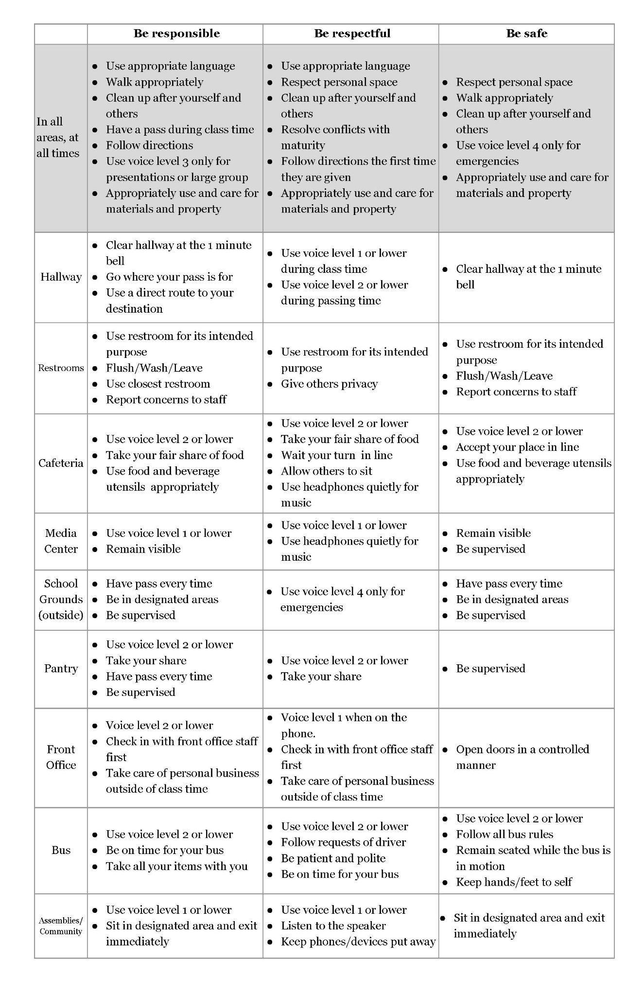
Windover High School
Voice Levels

Voice Level | Description
4 - Four | Outside voice/Yelling
3 - Three | Presentation Voice
2 - Two | Speaking; One-on-one with partner
1 - One | Whisper
0 - Zero | No Talking

Bulldog Buck Incentive Program

Students will earn bulldog bucks based on positive behavior choices made in the building on a weekly basis. Bulldog bucks will be collected throughout the school year.

How do bulldog bucks get entered into a student's account?

On a weekly basis students get bulldog bucks deposited into their account in the following ways:

1.) Students submit a deposit slip with their grades for each class and their attendance for each class to their advisory teacher. The slip is verified for accuracy and entered into the bulldog accounts.
2.) Teachers will submit a deposit slip with bulldog bucks for the student's behavior inside of the classroom.
3.) Success Coach, Principal, and Dean of students will submit deposit slips with bulldog bucks for student's behavior outside of the classroom.
4.) Each staff member will award one Bulldog Bonus to a student who displayed a random act of respect, responsibility or a behavior that kept the building safe.

What can students spend their bulldog bucks on?

Monthly students who were awarded Bulldog Bonus' will be put into a drawing for their choice of a free incentive.

All students with a positive balance in their Bulldog account will be eligible to participate in the end of the trimester activities.Students must also have a certain balance in their account to participate in field trips and in building fun activities.

BEHAVIOR EXPECTATIONS

It is the job of all staff of Windover to keep the students and the building safe on a daily basis. Students are expected to cooperate in a respectful manner when they are given a directive or asked a question by a staff member.

This list applies to conduct or conditions during the school day and on all school-sponsored activities, on or off school property. This is not an exhaustive list. Categories of misconduct which appear below could result in disciplinary action ranging from community restitution to expulsion.

AGGRESSIVE PHYSICAL CONTACT
- The act of quarreling with minimal bodily contact in or on school property, or intentionally causing or attempting to cause physical harm to another through force.

CELL PHONES AND ELECTRONIC DEVICES
Windover is an “away for the day school. This means that students are not allowed to carry or use Cell phones at anytime during the school day. Personal electronic communication devices (e.g. smartwatch with communication access), must be disabled while the student is at school.
● School phones are available in the school office should a student need to contact their parent/guardian.
● Additionally, if a parent needs to get a message to their child, they may call the office. ● If a student brings a cell phone to school for after school use, it will be the student’s responsibility to ensure that the phone remains off and is stored with the office for the entirety of the school day.

Using a cellular telephone, smartphone, video recording device, or similar electronic device in any manner that disrupts the educational environment or violates the rights of others, including using the device to take photographs in bathrooms, cheat, or otherwise violate student conduct rules.

Prohibited conduct specifically includes, without limitation, creating and sending, sharing, viewing, receiving or possessing an indecent visual depiction of oneself or another person through the use of a computer, electronic communication device or cellular telephone, commonly known as “sexting.” Unless otherwise banned under this policy or by the building principal, all cellular phones, smartphones and other electronic devices must be kept powered-off and out-of-sight during classroom instruction unless: (a) the supervising teacher grants permission; (b) use of the device is provided in a student’s individualized education program (IEP); (c) it is used during the student’s lunch period; or (d) it is needed in an emergency that threatens the safety of students, staff, or other individuals.

DRUGS AND ALCOHOL
- The Drug-Free Schools and Communities Act Amendments of 1989, P.L. No. 101 - 226 require that Windover High School maintain an environment free from the unlawful use, sale, manufacturing, dispensing or possession of drugs, controlled substances, or alcohol on school district premises during district activities.
- Any student found to be in violation of the above law will be subject to disciplinary action up to and including suspension or expulsion. The list of banned substances will also include any chemical or product intended to be used as a drug i.e.; bath salts, K2 or Spice, etc.
- Students may not have any medications in their possession or vehicle on school property. If a student must take any medication during school hours, it must be kept in the student's file in the main office. All medications must be in a bottle labeled with the student's name and the name of the prescription if applicable.
- Students may not possess or consume any performance-enhancing drugs while on school property; this includes caffeine pills and energy drinks.
- Any violation of the above-mentioned rules will result in suspension from school for a minimum of five (5) days and could result in long-term expulsion.
- Any additional offenses will result in a minimum suspension from school for the remainder of the school year and possible expulsion. Parents and guardians will be notified by phone and by mail.
- Students experiencing substance dependency-related problems may request a leave of absence to participate in counseling or a treatment program.

EXTORTION
- Is the act of securing or attempting to secure money or other items of value by the use of threats and/or violence or without the mutual consent of both parties involved.

GANG ACTIVITY
- No student on or around school premises shall
  - Wear, possess, use, distribute or display gang clothing, emblems, symbols, signs, or other things which are evidence of gang membership or affiliation in any gang;
  - Commit any act or use any speech or gesture showing membership in a gang;
  - Further the expansion of gangs in any way.

HARASSMENT
- Harassment in any form is unlawful. An individual who believes he/she has been subject to harassment should promptly notify the principal or school counselor. Under no circumstances will the student be required to notify the alleged offender. Sexual Harassment is the abuse of the dignity of anyone through sexist slurs or through other objectionable or derogatory conduct
- All staff members or volunteers with reason to believe sexual harassment of a student is occurring have the duty to report such information. Failure to report known sexual harassment of a student by an employee or volunteer may result in disciplinary action.
- Harassment complaints will be dealt with promptly in the following manner:
  - A written complaint will be made including the date, time, action(s) and possible witnesses.
  - The written complaint will be submitted to the appropriate authorized person.
- The designated investigator will:
  - Notify alleged perpetrator of the complaint.
  - Notify parents/guardians if the student is a minor.
  - Investigate the complaint by talking with any listed witnesses.
  - Review the alleged perpetrator's response.
  - Make a determination.
  - Maintain separate and secure files on the situation including notices, findings, and disciplinary sanctions.
- Discipline imposed may include student suspension or expulsion (depending on severity), written reprimand, recommendation for counseling referral or dismissal.
.
OBSCENITY AND INDECENCY
Offending against commonly recognized standards of good taste in dress or lack of dress; in language, either spoken or written; in pictures or drawings. If habitual could be considered sexual harassment. If this is the case a more severe consequence will be received by a student.

WINDOVER HIGH SCHOOL DRESS CODE
All students are required to be dressed appropriately for the academic setting as well as being
dressed appropriately for the weather. It is important to be clean and presentable while at
school or in the general public. Proper student attire is the student, parent/guardian, and school
officials’ responsibility.
1. Every student should make every effort to be clean when it concerns hygiene and
clothing. Please bathe when necessary and put on freshly laundered clothing before
coming to school.
2. Clothing or hygiene that presents a health or safety hazard to the student or other
students is not allowed (i.e. having visible signs of a hazardous material [by sight or
smell] such as flammable material like gasoline, oil, blood, human or animal waste).
3. Clothing or appearance that interferes with school work, creates disorder, or disrupts the
educational program is not allowed. Following are examples of what is not allowed, but
is by no means all inclusive:
Revealing or excessively tight clothing (cleavage showing, exposed undergarments,
see-through, short shorts, bare midriffs and sagging pants). Short-shorts or
skirts/dresses that do not surpass the end of the student’s fingertips with relaxed
shoulders are not permitted.
See through shirts, low cut shirts and shirts that do not cover the entire torso
Spaghetti strap tops, halter neck tops or tube tops. Straps on tops must be at least
two (2) fingers wide.
Clothing that sends a sexual, violent or discriminatory message, advocates drug or
alcohol use, violence, exhibits inappropriate language, is racially or sexually
offensive or contains inappropriate images or sayings
Grooming, clothing or jewelry that can prevent a student from achieving his/her own
educational objectives because of blocked vision or restricted movement
(sunglasses, hair combed over the eyes or other device designed to hinder or
change clear vision)
Blankets are not considered to be “clothing”.
4. Students that are considered to be in violation will be asked to correct the problem
immediately, utilizing the clothing pantry if necessary. The parent/guardian will be
contacted to bring proper attire if the student refuses to utilize the clothing pantry. If the
student continues to not cooperate, the student will be sent home. Habitual disregard for
the dress code will result in the student receiving a consequence for deliberate defiance.

PLAGIARISM/CHEATING
The intentional use of another person’s work presented as your own, in any amount, for consideration for a grade, credit, accolade, or any recognition will not be tolerated and WILL result in loss of credit and building consequence.

STEALING
The act of dishonestly acquiring and/or knowingly and willfully having in possession the property of another will result in automatic suspension and restitution.

USE OF TOBACCO PRODUCTS
The use of tobacco products on school property may lead to disciplinary action ranging from verbal warning to suspension. This includes electronic cigarettes and similar tobacco products.

VANDALISM
Defacing; hanging signs without permission; misuse of school property, building, or a classmate’s personal property will result in disciplinary action. Damages to Windover or classmates' property caused by vandalism will be paid for by responsible individuals or collectively paid for out of incentive money.

VERBAL ASSAULT
An oral conflict that is aggressive in nature.

There are infractions that Windover High School is mandated to act on in accordance with the law. The list below are these infractions and the minimum consequences that will be given to students.

WEAPONS
- No weapons of any kind are allowed at Windover High School. Possession of guns, knives with a 3-inch blade or longer and/or any weapon-like device being used with the intent to cause or threaten bodily harm are not allowed on school grounds and will result in mandatory expulsion and referral to the criminal justice system.
- Possessing or using a gun or other weapon as outlined in the federal Gun-Free Schools Act of 1994 will result in immediate and permanent expulsion and referral to the criminal justice system.

ARSON
The willful or malicious burning of, or attempt to burn, any buildings, or part of any building, structure, or property of the school district will result in expulsion.

VIOLENCE OR THREAT OF VIOLENCE (AGAINST FELLOW STUDENT OR STAFF)
This will not be tolerated (physical or verbal). The first offense will result in a one (1) to ten (10) day suspension depending on the nature of the incident. Additional offenses may result in suspension up to expulsion.

CRIMINAL SEXUAL CONDUCT
First through fourth-degree criminal sexual conduct as outlined in the state penal code and assault with intent to commit the same. Will result in an immediate recommendation for long-term suspension.

STATE OR DISTRICT MANDATORY EXPULSIONS

OFFENSE | GRADE LEVEL | LENGTH OF  EXPULSION | REINSTATE-MENT PROVISIONS | ENROLL AT  OTHER PUBLIC SCHOOLS?
Firearm/  Dangerous  Weapon | K – 12 | Permanent, subject to reinstatement at the discretion of the Board of Directors | Can apply after 150 school days, can be reinstated after 180 school days | No
Arson | K – 12 | Permanent, subject to reinstatement at the discretion of the Board of Directors | Can apply after 150 school days, can be reinstated after 180 school days | No
Criminal Sexual  Conduct | K – 12 | Permanent, subject to reinstatement at the discretion of the Board of Directors | Can apply after 150 school days, can be reinstated after 180 school days | No
Physical Assault  Against an Employee or Volunteer | Grade 6 & above | Permanent, subject to reinstatement at the discretion of the Board of Directors | Can apply after 150 school days, can be reinstated after 180 school days | No
Physical Assault  Against Another  Student | Grade 6 & above | Suspension or expulsion of up to 180 school days as determined by the Board of Directors or superintendent | Automatic at the end of the expulsion period. | Yes, if another public school agrees to accept the expelled student.
Verbal Assault  Against an Employee or Volunteer | Grade 6 & above | Suspension or expulsion for a period of time as determined at the discretion of the Board of Directors or superintendent | Automatic at the end of expulsion period. | Yes, if another public school agrees to accept the expelled student.
Bomb Threats/Other Threats | Grade 6 & above | Suspension or expulsion for a period of time as determined at the discretion of the Board of Education or superintendent | Automatic at the end of expulsion period. | Yes, if another public school agrees to accept the expelled student.

SEARCH AND SEIZURE
It is our priority to provide a safe learning environment for all of our students and staff. There may be times when that safety is in question because of some action or information that could present a potential danger or harm. This may require the principal or a designee having to search a student’s property (including but not limited to backpacks, jackets, pockets, purses) and/or vehicle on school property. School law requires that the search be justified at its inception and reasonable in its scope, given the initial justification for the search. Searches will be conducted with at least two adults present.

If this action results in the confiscation of contraband, the appropriate police authorities will be notified and the items will be turned over to them. This action could result in prosecution.

There may be times when law enforcement officials ask to speak with students on school property. The principal will cooperate with the officials in all reasonable requests. Parents of students aged 15 and 16 will be notified in reasonable time if their student is involved. Students who are 17 and older are considered adults and do not need parental permission.

SECLUSION AND RESTRAINT
The Windover High School Board of Education has adopted a policy on seclusion and restraint consistent with the Michigan Department of Education Policy which was approved by the Michigan State Board of Education on March 14, 2016; Amended on July 20, 2017; [http://www.michigan.gov/documents/mde/PolicyForSeclusion-Restraint_564940_7.pdf.]. This policy includes language on seclusion; restraint; emergency seclusion; emergency restraint and procedures for documenting and communicating such occurrences.

RESPONSES AND INTERVENTIONS

RESTORATIVE PRACTICES
If the District determines that it will utilize restorative practices in addition to or as an alternative to suspension or expulsion of a student, it will engage in restorative practices which emphasize repairing the harm to the victim and school community caused by the student’s misconduct.

Restorative practices may include victim-offender conferences that:
a) are initiated by the victim;
b) are approved by the victim's parent or legal guardian or, if the victim is at least fifteen (15), by the victim;
c) are attended voluntarily by the victim, a victim advocate, the offender, members of the school community, and supporters of the victim and the offender (the "restorative practices team");
d) would provide an opportunity for the offender to accept responsibility for the harm caused to those affected, and to participate in setting consequences to repair the harm, such as requiring the student to apologize; participate in community service, restoration of emotional or material losses, or counseling; pay restitution; or any combination of these.
The selected consequences and time limits for their completion will be incorporated into an agreement to be signed by all participants.

RESTORATIVE CIRCLES
Students with repeated conflict with peers or staff will work with the Dean of Students to resolve the issue and create a plan that includes support and interventions for the student.
- IN-CLASS SUPPORT – A possible outcome of a restorative circle, students who have been repeatedly sent out of the classroom, have participated in responsible circles will be provided with a 1 to 1 support staff to support their efforts to make behavioral changes.

RESTORATIVE MEETING
Students who have worked with the Dean of Students in a restorative circle and still continue to have difficulty meeting in the classroom or building expectations will participate in a restorative meeting. The meeting will include those who have acknowledged causing harm with, Dean of Students, Social Worker, and Principal. Supporters may also be in attendance.
- IN-CLASS SUPPORT – A possible outcome of a restorative meeting, students who have been repeatedly sent out of classroom, have participated in responsible circles will be provided with a 1 to 1 support staff to support their efforts to make behavioral changes.

RESTORATIVE CONFERENCE
Students who have worked with the Dean of Students in a responsive circle and restorative meetings and still continue to have difficulty meeting classroom or building expectations will participate in a restorative conference. The meeting will include those who have to acknowledge causing harm with, Dean of Students, Social Worker, Parent or Adult support person and Principal. Supporters may also be in attendance. May also be held when a student has been sent home on suspension as part of re-entry.

MINDFULNESS
Mindfulness interventions help maintain a moment-by-moment awareness of students’ thoughts, emotions, and the surrounding environment. Mindfulness is used to reduce stress and enhance social, emotional and cognitive development. This type of intervention gives students a chance to learn self-awareness and healthy habits, instead of falling into patterns of destructive behavior that could have potentially devastating consequences for their long-term health.

SUSPENSION PROCEDURE
The suspension is defined as the denial of the right to attend school for a specified period of time. If a student is suspended by the principal, the following procedures will be followed:

1. The principal will determine when a suspension is appropriate. The principal may suspend a student for up to 10 school days. The Board of Directors may suspend a student for up to 180 days.
2. The principal shall explain to the student all charges against the student, setting forth the nature, time and place of the violation charged and the duration of the suspension, which may be up to ten school days. Parents or guardians will be notified of the suspension by phone and a written copy may be mailed.
- The written notice shall include the time, place, and date of a hearing if a hearing is deemed necessary prior to the student being readmitted to school. The written notice shall advise the student and parent or guardian of the right to have counsel present at the hearing. The hearing on the charges shall be presided over by the principal and shall be conducted so that both sides shall have full opportunity to be heard, including the right to hear and examine adverse witnesses and the right to testify and present evidence or affidavits on one's own behalf.
- When a suspension is involved, the fundamental rights of the students must be respected.
a. Right of students to be informed of the charges against them. The charges should be specific, setting forth the nature, time, and place of the violation charged.
b. A right of students to be heard and present their view of the occurrence. Right of students not to be judged guilty simply by virtue of being accused.
- Within five school days of the conclusion of the hearing, the principal shall make a written report of the findings of fact, conclusions as to the validity of the charges, and the principal's decision regarding readmittance. The report shall be filed with the Chief Administrative Officer (CAO) and a copy shall be mailed to the student and the parent or guardian.
- After the student, parent, or guardian has exhausted the appeal process at the building level, the decision may be appealed to the CAO and the Board of Directors, in that order.

SNAP SUSPENSION
Snap suspension by a teacher is defined as the denial of the right to attend a class, subject or activity for the period of that class. If a student is suspended by a teacher, the following procedures shall be followed:

1. The teacher will determine that the student's behavior violated the provisions of the Code of Student Conduct, other than that such conduct requires expulsion. The teacher may suspend the student from the class, subject or activity for up to one school day.
2. The teacher shall explain to the student the reason for the suspension and shall immediately send the pupil to the principal’s office and report the suspension and the reason for the suspension to the principal.
3. The principal will take appropriate action, consistent with the Code of Student Conduct. The student will be sent home for the remainder of the day.
4. As soon as possible, the teacher shall contact the student's parent or guardian to set up a parent-teacher conference regarding the suspension. Under normal circumstances, the contact with the parent should be made the same day.
5. Whenever practicable, a school counselor shall attend the conference. The principal shall attend the conference if the teacher or parent or guardian so requests.
6. The teacher will fill out a written form detailing the reason for the suspension. A copy will be furnished to the parent at the conference and the original kept in the student's discipline file.
7. The parent or guardian and student may appeal the suspension to the principal. Due process procedures will be followed as detailed previously.

EXPULSION PROCEDURE
Expulsion is defined as the denial of the right to attend school for a period longer than 10 days. Only the Board of Directors can permanently expel or can reinstate a student who has been permanently expelled. If it is the judgment of the administrator that a student should be recommended for expulsion, the following procedures shall be followed:

- The principal shall contact the Board President each time a student is suspended and might be expelled. Their discussion will include the nature of the offense, supporting information, and student data justifying the recommendation.
- Parents will be notified by phone and subsequently, by mail that the student has been suspended.
- If the principal/CAO concur that the student should be denied the privilege of attending school for more than 10 days or a possibility of being suspended for up to 180 school days, the principal will call for a hearing with the Discipline Committee. The student and parents should attend the meeting so the student can have due process.
- After hearing the evidence, if the Discipline Committee recommends expulsion, the student and parent or guardian will be notified that such a recommendation will be presented to the Board of Directors.
- The student and parent or guardian will be notified of the following:
- The nature of the recommendation
- The date, time, and place the recommendation will be presented to the Board of Directors
- The right to be present and participate in the proceedings in person and/or by legal counsel.
- The right to request an open or closed hearing with the Board.
- The information furnished to the Board of Directors shall include the following:
- A record of all preliminary procedures
- The recommendation that the student is to be expelled and the duration of the expulsion
- The justification for the recommendation

REINSTATEMENT PROCEDURES
A student who is expelled from Windover High School for physical assault against another student, verbal assault against an employee or volunteer, or bomb threat or similar threat may be automatically reinstated at the end of his or her period of expulsion. The school will contact the student and parent or guardian if a petition for reinstatement is needed. The district may request a conference with the student and parent or guardian before the student is readmitted to school so that plans can be made for a smooth transition back into the school setting.

It is the responsibility of the parent or legal guardian or, if the individual is at least age 18 or an emancipated minor, to prepare and submit a petition for reinstatement. The State Department of Education is required by law to develop and distribute to all school districts a form for petitions for reinstatement. The school district is required to make this form available, but the Board of Directors is not required to provide any assistance in preparing the petition. Upon request, the form will be made available by the administrator.

No later than ten school days after a petition for reinstatement is filed, the Board of Directors will appoint a committee to review the petition and any additional information supplied by both the petitioner and school personnel. The committee will consist of one board member, the principal, one teacher and two parents each having a pupil enrolled in the school. The school’s principal may prepare and submit information concerning the circumstances of the expulsion and any factors mitigating for or against reinstatement.

No longer than ten school days after the committee is appointed, it will meet, review all information, and submit a recommendation to the board. In all reinstatement situations other than those that are automatic as dictated by statute, the recommendation shall be for unconditional reinstatement, for conditional reinstatement, or against reinstatement, and shall be accompanied by an explanation of the reasons for the recommendation and of any recommended conditions for reinstatement. The recommendation shall be based on consideration of all of the following factors:
- The extent to which reinstatement of the individual would create a risk of harm to pupils or school personnel.
- The extent to which reinstatement of the individual would create a risk of school district or individual liability for the school board or school district personnel
- The age and maturity of the individual.
- The individual’s school record before the incident that caused the expulsion.
- The individual’s attitude concerning the incident that caused the expulsion.
- The individual’s behavior since the expulsion and the prospects for remediation of the individual.
- If the petition was filed by a parent or legal guardian, the degree of cooperation and support that has been provided by the parent or legal guardian and that can be expected if the individual is reinstated, including, but not limited to, receptiveness toward possible conditions placed on the reinstatement.

At the next regularly-scheduled board meeting after receiving the committee’s recommendation, the board will make a decision to unconditionally reinstate the individual, conditionally reinstate the individual, or deny reinstatement of the individual. The decision of the board shall be final.

The board may require the student and his or her parent or legal guardian to agree in writing to specific conditions before reinstating the individual in a conditional reinstatement. The conditions may include, but are not limited to, the agreement to a behavior contract, which may involve the individual, parent or legal guardian, and an outside agency; participation in or completion of an anger management program or other appropriate counseling; periodic progress reviews; and specified immediate consequences for failure to abide by a condition. The petitioner also may include proposed conditions in a petition for reinstatement.

If the board denies a petition for reinstatement, the parent or legal guardian or, if the student is at least age 18 or is an emancipated minor, the student may petition another school board for enrollment in the other school district.

The board or school administrator who complies with the state law regarding expulsions is not liable for damages for expelling a student.

WEAPONS REPORTING
Students are required to report any knowledge of weapons being present on school grounds or of any threats of violence being made. This information must be reported immediately to the Principal or any available member of the staff in the absence of the principal. Failure to report such knowledge may subject the student to discipline, up to and including expulsion.
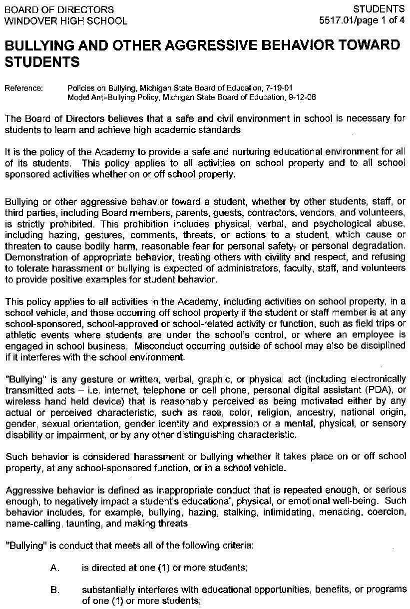
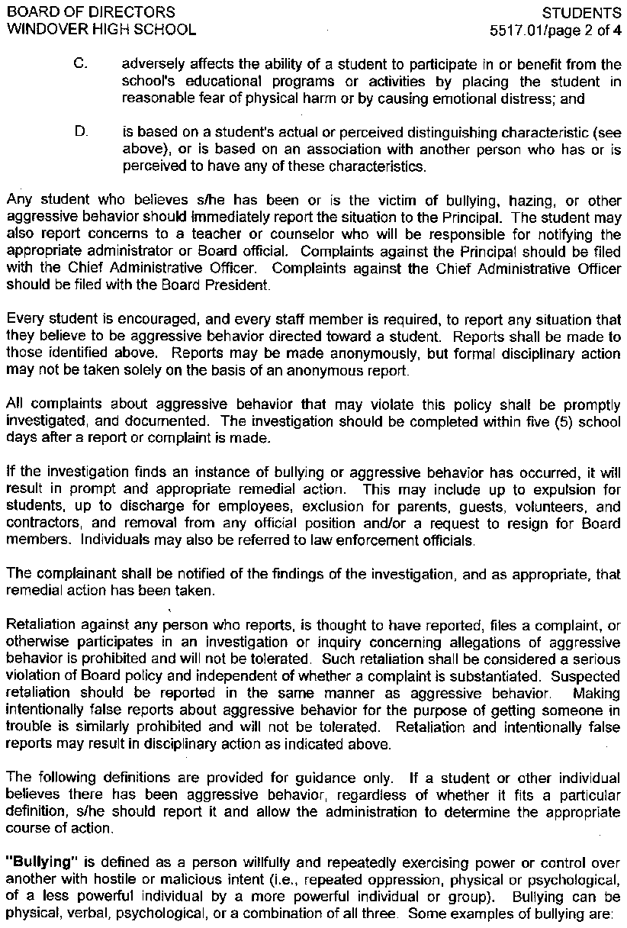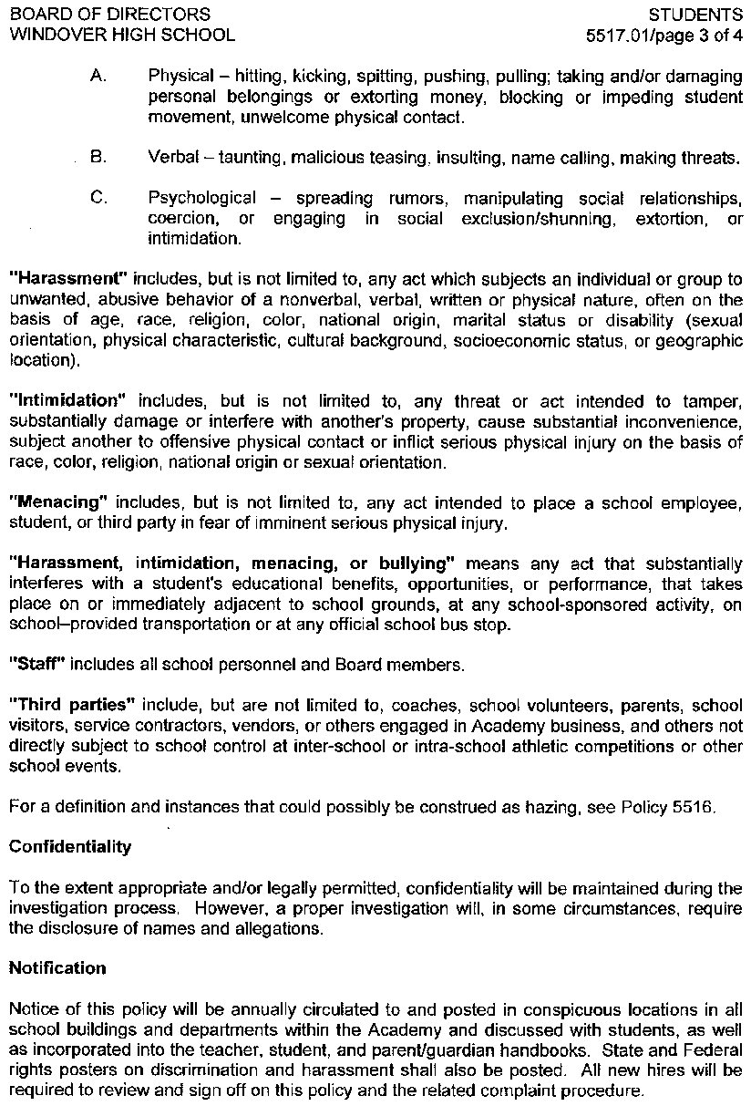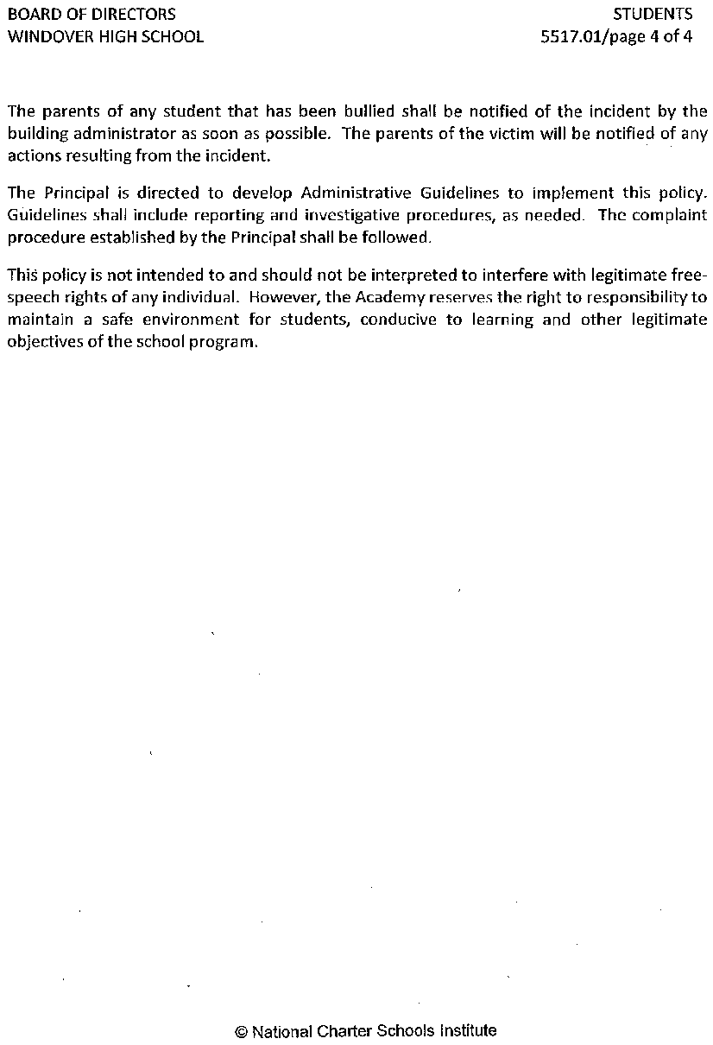
WHS Computer/Technology Use Policy for Students

COMPUTER USE

We require that students and parents accept, and sign the following rules for acceptable use of technology. Access to the Internet and the use of the computer network is provided to students who agree to act in a considerate and responsible manner. The use of the Internet is a privilege, not a right, and inappropriate use will result in a cancellation of those privileges. The faculty and staff of Windover High School reserve the right to request the administrator to suspend specific user accounts.

In accordance with the Children’s Internet Protection Act (CIPA) all WHS students will access the Internet through an appropriate filter that blocks objectionable (inappropriate and harmful) material. Objectionable material is defined as any visual depiction of obscenity, pornography, or other depictions not appropriate for students. The filter is set to automatically block these kinds of web pages. Sites that advocate antisocial behavior will also be blocked to the extent
possible. The safety and security of WHS students are of utmost importance. It is expected that students will never give personal information to a stranger by way of email, chat rooms, or other forms of electronic communications.

- Students are responsible for appropriate behavior on the Windover High School Network. General school rules for behavior and communications apply to the Internet.
- Network administrators may review files and communications to maintain system integrity and ensure that users are using the system responsibly. Users should not expect that files are private.
- USERS ARE PROHIBITED FROM using the technology for a “for-profit” business, for product advertisement or political lobbying the malicious use of technology to disrupt the use of technology by others, to harass or to discriminate against others, and to infiltrate unauthorized computer systems using Windover High School information technologies to draft, send, or receive inappropriate communications and material including but not limited to items which are pornographic, obscene, profane, vulgar, harassing, threatening, defamatory or otherwise prohibited by law participating in hate mail, harassment, discriminatory remarks and other antisocial behaviors on the network vandalizing Windover High School or any other information technologies (Windover High School’s or any others). Vandalism is defined as any attempt to harm, destroy, disrupt or hack the operation of the Windover High School Network. Vandalism includes, but is not limited to, the creation or intentional receipt or transmission of computer viruses

Consequences of Inappropriate Behavior:
Windover High School’s system is not a public forum and access to technology is a privilege and not a right. Any user who does not comply with the Electronic Information Access and Use Policy will lose network privileges. Repeated or severe infractions of the policy may result in permanent termination of privileges. Users violating any of the rights and responsibilities may face additional disciplinary action deemed appropriate in keeping with the disciplinary policies and guidelines of the school.

WHS ELECTRONIC INFO AND USE FOR EDUCATIONAL PURPOSES
MEMBER RESPONSIBILITY DECLARATION

- Windover High School has developed an Electronic Information Access and Use for Educational Purposes Policy for the Internet, local and wide area networks, computers, and related equipment.
- Access to and use of the Internet, local and wide area networks, computers, and related equipment is a privilege for the user.
- I have read, understand, and will abide by the Electronic Information Access and Use Policy and this agreement.
- I understand that should I commit any violation, my privileges may be revoked, school disciplinary action, and/or appropriate legal action may be taken.
- Members having accounts on the Windover High School Network should be advised that they might locate the material that could be considered offensive or controversial.
- Parents of minors should be aware of the existence of such materials and monitor home usage of the system.
- Students knowingly bringing or downloading such material into the school environment will be dealt with according to the discipline policies of Windover High School and such activities may result in termination of their account on the network.
- In consideration for the privilege of using the WHS Network and in consideration for having access to the information contained or accessed on it, I hereby release Windover High School and its operators and sponsors, its faculty and staff, and all organizations, groups, and institutions with which WHS is affiliated for any and all claims of any nature arising from my use, my child’s use or inability to use of the WHS Network.

CHROMEBOOK USE
Receiving a Chromebook

- Parents/guardians and students must sign and return the User Agreement and Parent Permission Form before a Chromebook is issued to the student.
- Chromebook will be labeled in a manner specified by WHS; this will include the serial number.
- The Chromebook and school issued email account are the property of WHS and as a result may be subject to inspection at any time. The student should have NO expectation of privacy of material found on a Chromebook or a school supplied or supported email service.
- Should your child be a virtual student and/or your child chooses to opt out of having a Chromebook, you will need to submit a signed note to that effect to WHS.

Students are responsible for following the Acceptable Use Policy and appropriate
handling of the device during school.

Taking Care of a Chromebook

Students are responsible for the general care of the Chromebook they have been issued by the WHS. Chromebooks that are broken or fail to work properly must be given to the District Technology Coordinator for an evaluation of the equipment. Care must be taken to protect the screen. Students are responsible for anything done using their assigned Chromebook or their login. Chromebooks are the property of the WHS and all users will follow these procedures and the WHS Computer Use Policy.

General Precautions

- While the Chromebook is considered scratch resistant, the Chromebook can scratch. Avoid using any sharp object(s) on the Chromebook.
- Chromebooks do not respond well to liquid. Avoid applying liquids to the Chromebook. The Chromebook can be cleaned with a soft, lint free cloth. Avoid getting moisture in the openings. Do not use window cleaners, household cleaners, aerosol sprays, solvents, alcohol, ammonia, or abrasives to clean the Chromebook.
- Do not close the lid with a pen/pencil or other objects inside as it will break the screen.
- Do not attempt to gain access to the internal electronics or repair of a Chromebook. If a Chromebook fails to work or is damaged, report the problem to the school.
- There is no “jailbreaking” (bypassing filters and controls) of this device.
- Never throw or slide a Chromebook.
- Cords and cables must be inserted carefully into the Chromebook to prevent damage.
- Chromebooks must remain free of any writing, drawing, stickers, or labels that are not the property of the WHS or approved by the building principal.
- Chromebooks may have the ability to be remotely located. Modifying, disabling, or attempting to disable the locator is a violation of the Electronic Information and Use Policy and grounds for disciplinary action.
- Chromebooks have a unique identification number and at no time should the number or labels be modified or removed.
- Chromebooks should be placed stored either vertically in a case or in a backpack/bookbag to avoid putting any pressure on the screen.
- Chromebooks must never be left in an unlocked car or in any unsupervised area.
- Chromebooks must not be left in a vehicle or a location that is not temperature controlled. Do not leave the Chromebook in your car in the winter!!
- Chromebooks must be charged for school each day. This is the student’s responsibility. Students will not be allowed to charge their devices in classrooms. If you can remember to charge your phone you can remember to charge your Chromebook.
- Chromebooks are assigned to individual students and the responsibility for the care of the Chromebook solely rests with that individual. Students should not lend their Chromebooks to another person.
- PLEASE DO NOT ATTEMPT TO CONTACT A SERVICE DIRECTLY FOR REPAIR QUESTIONS. PLEASE CONTACT THE SCHOOL.

Returning a Chromebook

- Chromebooks and all WHS accessories will be returned during the final weeks of school so they can be checked for serviceability.
- Chromebooks must be returned immediately when a student transfers out of the WHS, is suspended or expelled, or terminates enrollment for any reason.

Fines Related to a Chromebook
- Chromebooks and AC chargers will be turned in to the school, when requested, in satisfactory condition. Chromebooks will be inspected for damage. In the case of abuse, neglect, or intentional damage, the student/parent/guardian will be charged a fee for needed repairs, not to exceed the replacement cost of the Chromebook. The WHS Administration will make the final determination of any fees assessed.
- If a student fails to return the Chromebook, the student/parent/guardian will pay the replacement cost of the Chromebook. Failure to return the Chromebook will result in a theft report filed with the Midland Police Department.
- Parents will NOT be required to have insurance on the device. The school district will carry a policy that will cover the Chromebooks. However, the parents and students will be responsible for all costs associated with intentional damage, misuse, or neglect. Students may also be assessed a school fine of $25 for the first time a machine needs to be repaired, $50 for the second time a machine needs repair, and may possibly remove the student from the program if a machine needs to be repaired a third time.

Claims
- In cases of theft, vandalism, or other acts that may be covered by the school insurance, the student/parent/guardian must file a report with the principal before a Chromebook can be repaired or replaced.
- In the event of a lost or stolen Chromebook, WHS may deploy location software, which may aid in recovering the Chromebook.
- Failure to report a stolen Chromebook in a timely manner may result in a request for compensation for the replacement cost of the Chromebook.

Personal Home and Homeowners’/Renters’ Coverage

Lost, damaged, or stolen Chromebooks in the care, custody, and control of a student will be the responsibility of the parent and/or student for repair and or replacement.

Using the Chromebook Camera

The Chromebook may come equipped with a camera and video capacities. As with all recording devices, it is best practice and common courtesy to ask permission before recording an individual or group and notifying the individual or group if the image will be posted online. Cameras may never be used in a locker room or restroom per state statute.

Legal Propriety

- Comply with trademark and copyright laws and all license agreements. Ignorance of the law is not immunity. If you are unsure, ask the district technology coordinator.
- Plagiarism is a violation of the WHS rules. Give credit to all sources used, whether quoted or summarized. This includes all forms of media on the Internet, such as graphics, movies, music, and text.
- Use or possession of hacking software is strictly prohibited and violators will be subject to WHS discipline. Violation of applicable state or federal law may result in criminal prosecution.

Screensavers/Background photos

While personalized screensavers or backgrounds are permitted, inappropriate or provocative images including but not limited to pornographic images, guns, weapons, inappropriate language, threatening language, drug, alcohol, or gang-related images are not permitted and subject to disciplinary action.

Sound, Music, Games, Software/Apps

- Sound must be muted at all times unless permission is obtained from the teacher for instructional purposes.
- Students should provide their own headsets/earbuds.
- Music is only allowed on the Chromebook at the discretion of the teacher.
- All software/apps must be district provided. Data storage will be through apps on the Chromebook, i.e. Google Docs, Notepad, etc.
- Internet games are not allowed on the WHS Chromebooks.

Using a Chromebook at School

Chromebooks are intended for use at school each day. In addition to teacher expectations for the Chromebook use, school messages, announcements, procedures and rules, calendars, and schedules may be accessed using the Chromebook. Students are responsible for bringing their Chromebook to all classes unless specifically instructed not to do so by a teacher.

Chromebook Undergoing Repair

Loaner Chromebooks may be issued to students when their Chromebooks are being
repaired by the school. A limited number of “loaner” Chromebooks are available so
having a “loaner” is not guaranteed.

Network Connectivity

WHS makes no guarantee that the district’s network will be up and running 100% of the time. In the rare case that the network is down, the district will not be responsible for lost or missing data.

User Signature:___________________________Date:______/_______/______

Parent Signature:_________________________Date:______/_______/______

